Development and evaluation of the AUB Middle Eastern collection:

The use of bibliometric-based indicators

*The paper provides an overview of the selection and evaluation process of the Middle Eastern studies books collection at the American University of Beirut in Arabic and Western languages. The policy related to this collection will be highlighted, along with the use of bibliometrics to the selection and collection evaluation processes. In particular bibliometrics (h-index, scopus, GS, etc.) applied to the AUB ME collection will give quantitative and qualitative description of the collection*

1. **Literature review**

Collection Development Departments (CDD) rely on various methods to develop and evaluate monograph collection in Academic Libraries. From syllabi examination (Smith, D. A., 2008) and faculty involvement (Ameen & Haider, 2007) to focus groups, through surveys and instructions sessions (Schmidt, K. 2004) along with peer universities comparisons. CDD decisions are achieved through a combination of criteria to support the book selection process and to evaluate the quality, value, or impact of a book, e.g. the authority and reputation of both author and publisher, the range of price, level of coverage, language, topic, format (print, electronic, DVD, etc.), genealogy (newer editions do not necessarily mean revised editions - Original editions versus reprints), purpose (teaching, research, personal), uniqueness, appropriateness to the subject covered (Schmidt, 1984), the book review itself, the topic and its relevance to the programs taught.

If the publisher authority and reputation is considered, limited studies showed the availability of publisher quality assessment (Lewis, July 2000), while a subjective judgment is applied to publisher’s attributing quality [1](Metz, P. & Stemmer, J., May 1996).

1. **Bibliometrics applied to Selection**

Thus, along with the aforementioned criteria, and for a quantitative collection development and evaluation, Jafet library at AUB relies on, but does not limit its evaluation to, Bibliometric-Based Indicators (BBI).

Another reason to rely on (BBI) is related to Jafet library space limitations, in addition to a significant annual budget allocated to monographic acquisitions. Faculty members’ book requests are being questioned in order to develop a relevant collection. Thus, more than 1000 requests are rejected yearly while 1% of the faculty members ask back for their books. Bibliometric data is neither applied to books requested for a course nor to those related to research purposes; it is applied to all other requests in Western Language, mainly English.

Historically, in the third century, the counting of the Ancient Library of Alexandria’s scrolls is considered as to be the forerunner of modern bibliometrics, while bibliometrics are defined as “the use of statistical data to analyze patterns of books production and scholarly communication”[2] (Nisonger, 1992). Bibliometrics define how influential the author has been in the past, giving an idea of the number of works an author/editor has published and the number of times each work has been cited. In short, it allows assessing both the quantity and “quality” of an author’s/editor’s work. Hirsch states that, “the publication record of an individual and the citation record clearly are data that contain useful information” (Hirsch, 2005).

It has been used mainly to distinguish the most productive authors and institutions and identify research experts (Nisonger, 1992); H-index, WoS, Scopus and GS were created for citation searching and bibliometric analysis (Meho, L. & Yang, H., November 2007).

1. **New publications Middle Eastern Western Collection**

* *Authored book*

At AUB libraries the average number of citations required to build a decision of purchasing versus non-purchasing a recent book, depends on the field of study: citation counts of scientific books are usually higher than humanities books.

To evaluate a book using bibliometric data, the first step is to look at its publication and copyright year:

* 1. If before 2004, check:

Number of citations in Scopus and/or Google Scholar (disregard all other bibliometric-based indicators/tools)

* 1. If 2004-2008, check:

- Number of citations in Scopus and/or Google Scholar; AND

- H-index of author/editor in Scopus and/or Google Scholar

* 1. If after 2008, check:

- H-index of author/editor in Scopus and/or Google Scholar

Before 2004: this will give the book plenty of time (10 years or more) to get known and be cited to accurately determine its impact or lack of it

2004-2008: 5-9 years may or may not be enough for a book to get well known and be cited to accurately determine its impact or lack of it – this is why two indicators are used for such books

After 2008: 5 years or less are not enough for a book to get well known and be cited to accurately determine its impact or lack of it – this is why we do not use citation count of books in this case and instead use the h-index of the author/editor

1. **New publications -ME Arabic collection: *AUB collection development policy***

As for Arabic books in the same field, where bibliometrics do not apply, CDAD rely on the publisher mainly. AUB collection development policy states that a book should not be a reprint a re-issue or a republication by a different publisher or under a slightly changed title. Translations are avoided. Materials written for a juvenile rather than an academic audience are not selected; neither recreational reading, commercial and poor publications with little value as academic resources; nor textbooks, except when they are only/most appropriate source of information on a subject. Outdated materials are acquired when related to disciplines such as History, Middle Eastern and Islamic studies, Arabic Literature, etc. or a recognized classic with demonstrable research value. No duplicate copies, unless material is in high demand.

1. **BBI applied to collection** **evaluation**

As previously stated, Bibliometrics can be one of the monographs selection criteria. Similarly, it can also be used to define the level of collection relevancy conferring to information user needs and library goal achievement, along with evaluating collection quality (Nisonger, 1992). (Adams, B. & Noel, B., 2008) explain that analysis and quantitative feedback will improve collection development’s future acquisitions, detecting area of over selection. The strengths and weaknesses of subject classes can be assessed quantitatively. The h-index defines the threshold upon which the collection improvement stands.

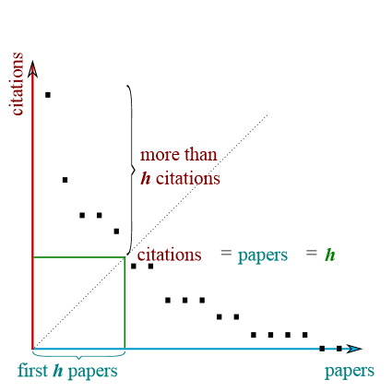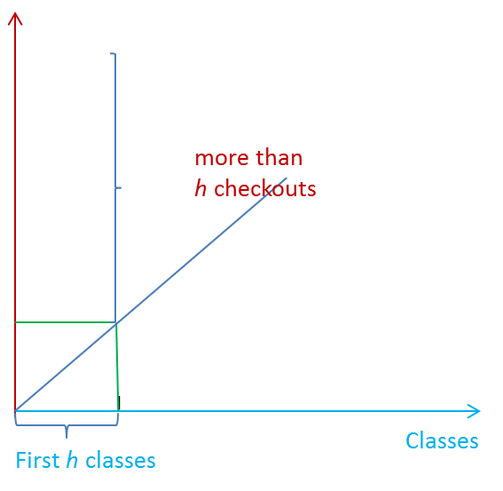

Checkouts

Kim, Lee, & Park, (2009)

As the original h-index, collection evaluation h-index is defined as follows; “A subject category has index *h* if *h* of its number of books (*Nb*) has at least *h* circulations each and the other (*Nb-h*) books have ≤ *h* citations each”[3] (Kim, Lee, & Park, 2009).

Collection evaluation h-index is applied to library circulation data, which are easily accessible through automated systems, along with their DDC subject classes. In order to measure the ME collection strengths by subject according to circulated books, a project was conducted at AUB, targeting subject headings that include the term “Middle East”. We are assuming that we have a good subject index. The library is relaying on the LC classification, but since all areas are not developed equally, AUB libraries build on LC subject class.

Analysis only targeted hard books’ circulation of the ME collection available for open access from 1997 to 25-3-2013. Average circulation of interlibrary loan data was not considered, because of the novelty of the service at AUB. Middle Eastern special collections (Manuscripts and rare books), which are non-circulated materials, were also excluded. The open stacks, since two years, may have influenced the results, and user behavior and performance.

Total Checkout per DDC versus checkout

Western ME collection

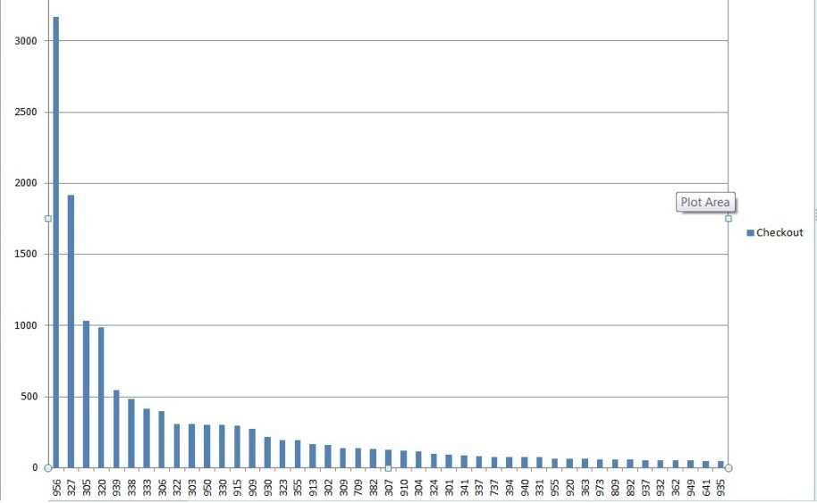

We can notice that the 956 field is highly cited, followed by 327, 305 and 320, etc.

|  |  |  |  |  |  |
| --- | --- | --- | --- | --- | --- |
| **Sorting by total checkout** | **Class number by DDC** | | **Number of Books** | **Total Checkout** | **h-index=45** |
| **1** | Middle East | 956 | 924 | 3165 |  |
| **2** | Political Science- International Relations | 327 | 506 | 1913 |
| **3** | Groups of people | 305 | 99 | 1030 |
| **4** | Political science (Politics and government) | 320 | 219 | 988 |
| **5** | Other parts of ancient world | 939 | 171 | 542 |
| **6** | Production | 338 | 147 | 481 |
| **7** | Economics of land and energy | 333 | 64 | 411 |
| **8** | Culture and institutions | 306 | 50 | 396 |
| **9** | Relation of the state to organized groups and their members | 322 | 28 | 306 |
| **10** | Social processes | 303 | 62 | 306 |
| **11** | History of Asia | 950 | 29 | 301 |
| **12** | Economics | 330 | 135 | 299 |
| **20** | History of Sociology | 309 | 38 | 136 |
| **31** | General customs | 394 | 4 | 74 |
| **32** | General history of Europe | 940 | 53 | 72 |
| **33** | Labor economics | 331 | 13 | 71 |
| **34** | General history of Asia; Iran | 955 | 9 | 63 |
| **45** | History of ancient world; Mesopotamia & Iranian Plateau | 935 | 30 | 46 | h-index : 45 |
| **46** |  | 933 | 15 | 45 |  |

we notice e.g. that we need to invest more in Class #305, 322, 950 and 309 by acquiring new publications or maybe new copies of what is available.

Besides to fill the gaps in the 394 class, where AUB holds 4 titles, a research is undertaken in Harvard University Library, as one of the largest acquisitions libraries. The results showed more titles in this class.

But this does not mean that we will neglect what is beneath h-index threshold. Around 200 titles are not being checked out. The reasons need to be found

* They are either newly published, or subject to poor information retrieval: poor indexing/ subject classification.
* Those may be considered to be placed in a different location or even weeded if not highly cited.

These results will help in decision making, identifying the collection strengths and weaknesses by subject class

The figures related to the 956 class separately are the following

|  |  |
| --- | --- |
| **History of Asia - Middle East (Near East)** | **Figures** |
| Class number | 956 |
| Number of Books | 924 |
| Total Checkout Unique | 528 |
| % Collection Check Out | 57% |
| #Times Book was Checked Out | See next table |
| H-index | 24 |

Circulation of each book in 956 DDC class

|  |  |  |  |  |  |  |
| --- | --- | --- | --- | --- | --- | --- |
| Record Number | Title | Date | Publisher | Class | CallNo | Total CheckOut |
| i12363868 | Lebanon and the Middle Eastern question | 1988 | Centre for Lebanese Studies, | 956.92044 | J 956.92044:S165L:c.1 | 46 |
| i14076172 | Minorities in the Middle East : a history of struggle and self-expression / Mordechai Nisan | c2002 | McFarland, | 956.67 | J 956.67:N722m2:c.1 | 44 |
| i14025012 | From Beirut to Jerusalem : updated with a new chapter / Thomas L. Friedman | c1995 | Doubleday, | 956.04 | J 956.04:F911fb:c.1 | 42 |
| i1380070x | Power, politics, and culture: interviews with Edward W. Said / edited and with an introduction by Gauri Viswanathan. | c2001. | Random House, | 956 | J 956:S132p:c.1 | 41 |

Titles that circulate the most in each class and DDC class can be retrieved

We can retrieve data related to the 956 subfields. H-index=24

|  |  |  |  |  |  |
| --- | --- | --- | --- | --- | --- |
| **Sorting by total checkout** | **DDC 956 Subclass** | | **Number of Books** | **Total Checkout** | **h-index = 24** |
| **1** | 956 | Middle East (Near East) | 381 | 1036 |  |
| **2** | 04 | 1945-1980 | 103 | 481 |  |
| **3** | 67 | minority middle east | 21 | 193 |  |
| **4** | 05 | 1980- | 34 | 150 |  |
| **5** | 101 | Early history to 1918 | 11 | 107 |  |
| **6** | 9204 | 1926- | 13 | 98 |  |
| **7** | 053 | 1985-1999 | 18 | 96 |  |
| **8** | 94 | Palestine; Israel | 31 | 91 |  |
| **9** | 9 | Syria, Lebanon, Cyprus, Israel, Jordan | 67 | 80 |  |
| **10** | 7043 | *Iraq Period of Republic, 1958- | 13 | 75 |  |
| **11** | 01 | Early history to 1900 | 10 | 65 |  |
| **12** | 015 | 1300-1900 | 17 | 65 |  |
| **13** | 92044 | ‡Period of civil war and religious strife, 1975-1990 | 5 | 65 |  |
| **14** | 02 | 1900-1918 | 6 | 51 |

8 books in Harvard

  |
| **15** | 7 | Iraq | 11 | 47 |  |
| **16** | 072 | orientalism | 5 | 45 |  |
| **17** | 03 | 1918-1945 | 12 | 45 |  |
| **18** | 92043 | 1941- | 3 | 42 |  |
| **19** | 7044 | Iraq 1979- | 9 | 40 |  |
| **20** | 004 |  | 8 | 34 |  |
| **21** | 054 | Lebanon 2000- | 16 | 33 |  |
| **22** | 92 | Lebanon | 10 | 31 |  |
| **23** | 9405 | Jordan and West Bank 1923- | 10 | 31 |  |
| **24** | 052 | East central Turkey historical period | 1 | h-index 28 |  |

A similar analysis can be applied to the 956.04 subfield for each book

|  |  |  |  |  |  |
| --- | --- | --- | --- | --- | --- |
| **Sorting by total checkout** | **Number of Books** | **Total Checkout** | **Record number** | **Year of Publication** | **Title** |
| 1 | 1 | 42 | i14025012 | c1995 | From Beirut to Jerusalem : updated with a new chapter / Thomas L. Friedman |
| 2 | 1 | 28 | i14430447 | 2006, c2005 | The great war for civilization : the conquest of the Middle East / Robert Fisk |
| 3 | 1 | 22 | i14259515 | c2005 | Teta, mother and me : an Arab woman's memoir / Jean Said Makdisi |
| 4 | 1 | 20 | i12625073 | c1997 | The Cold War and the Middle East / edited by Yezid Sayigh and Avi Shlaim |
| 5 | 1 | 20 | i13729974 | 2000 | War, institutions, and social change in the Middle East / edited by Steven Heydemann |
| 6 | 1 | 17 | i13863058 | c2001, repr. 2002 | Conflicts in the Middle East since 1945 / Beverley Milton-Edwards and Peter Hinchcliffe |
| 7 | 1 | 16 | i13911144 | 2002 | A revolutionary year : the Middle East in 1958 / edited by Wm. Roger Louis and Roger Owen |
| 8 | 1 | 15 | i11572899 | c1993 | The politics of miscalculation in the Middle East / Richard B. Parker |
| 9 | 1 | 14 | i1348199x | c1998 | Conflict and war in the Middle East : from interstate war to new security / Bassam Tibi |
| 10 | 1 | 13 | i10745956 | 1988 | Ideology and power in the Middle East : studies in honor of George Lenczowski / edited by Peter J. Chelkowski |
| 11 | 1 | 13 | i14590918 | c2006 | Middle East historiographies : narrating the twentieth century / edited by Israel Gershoni, Amy Singer, Y. Hakan Erdem |
| 12 | 1 | 12 | i14618400 | c2006 | Palestine : peace not apartheid / Jimmy Carter |
| 13 | 1 | 12 | i14651816 |  | The Cold War in the Middle East : regional conflict and the superpowers, 1967-73 / edited by Nigel J. Ashton |

Titles that circulate the most in each class and DDC subclass can be retrieved.

Same can be applied to the Arabic ME collection

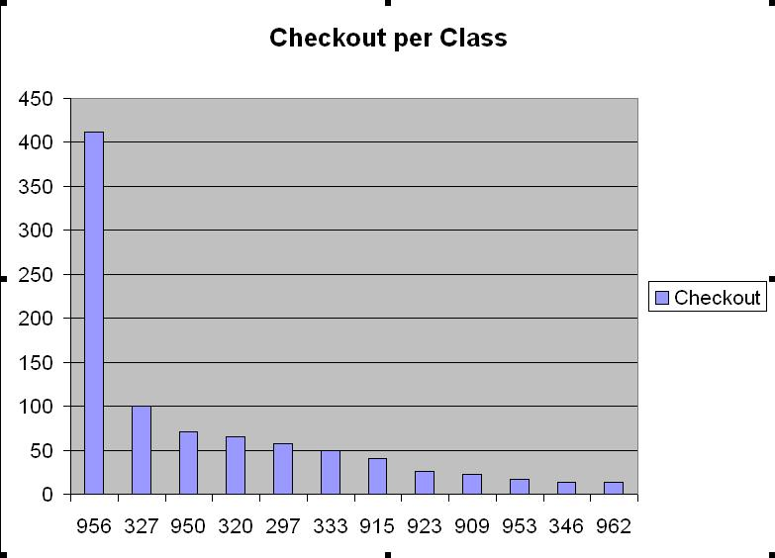

Total Checkout per DDC versus checkout

Arabic ME collection

|  |  |  |  |  |
| --- | --- | --- | --- | --- |
|  | ClassNo | NumberOfBooks | Total Checkout | h-index=12 |
| 1 | 956 | 199 | 412 |  |
| 2 | 327 | 58 | 100 |
| 3 | 950 | 8 | 71 |
| 10 | 953 | 10 | 17 |  |
| 11 | 346 | 5 | 14 |
| 12 | 962 | 5 | 13 |  |
|  | 338 | 22 | 12 |  |
|  | 330 | 10 | 12 |

Conclusion

Citation counts are powerful tools that must be used wisely; similar to other tools, they have their strengths and weaknesses. Citation tracking is sometimes limited to a period of time (e.g. scopus 1996+), poor indexing, non-scholarly citations (e.g. Google scholar), components and time span, updating period, coverage, etc. [4] However they remain the only tool that quantifies publications with an increasingly significant importance.

We will be investigating in the next few weeks other collections, or new methods to analyze our collection. It could be also interesting to establish a five years comparative study where h-index gives us a threshold for analysis.

Mariette Atallah, Ph.D.

Head/Collection Development and Acquisitions Department

Assistant Professor  
Sociology, Anthropology and Media Studies

American University of Beirut

Lebanon

mariette.atallah@aub.edu.lb

References

Adams, B. & Noel, B. (2008). Circulation statistics in the evaluation of collection development. *Collection Building, 27*(2), 71-73. doi: 10.1108/01604950810870227

Ameen, K., & Haider, S. J. (2007). Book selection strategies in university libraries of Pakistan: An analysis. *Library Collections, Acquisitions, & Technical Services*, 31 (3-4), 208-219. doi: [http://dx.doi.org/10.1016/j.lcats.2007.11.002](http://dx.doi.org.ezproxy.aub.edu.lb/10.1016/j.lcats.2007.11.002)

Hirsch, J. E. (2005). An index to quantify an individual's scientific research output. *Proceedings of the National Academy of Sciences of the United States of America, 102*(46), 16569-16572. doi: 10.1073/pnas.0507655102

Kim, P. J., Lee, J. Y., & Park, J. H. (2009). Developing a new collection -evaluation method:Mapping and the user-side h-index. *Journal of American Society for Information Science and Technolgy, 60*(11), 2366-2377.

Lewis, J. S. (July 2000). An assessment of publisher quality by political science librarian. *College & Research Libraries, 61*(4), 313-323.

Meho, L. & Yang, H. (November 2007). Impact on citation counts and rankings of LIS faculty: Web of science versus scopus and google scholar. *Journal of the American Society for Information Science and Technology, 58*(13), 2105-2125.

Metz, P. & Stemmer, J. (May 1996). A reputational study of academic publishers. *College & Research Libraries, 57*, 234-247.

Nisonger, T. E. (1992). *Collection evaluation in academic libraries: A literature guide and annotated bibliography*. Englewwod CO: Library unlimited.

Schmidt, J. B. (1984). Apparatus: A mnemoninic for the evaluation of reference resources. *The Reference Librarian, 4*(11), 301-311. doi: <http://dx.doi.org/10.1300/J120v04n11_23>

Schmidt, K. (2004). Past perfect, future tense: A survey of issues in collection development. *Library Collections, Acquisitions & Technical Services*, 28, 360-372.

doi: [http://dx.doi.org/10.1016/j.lcats.2004.08.012](http://dx.doi.org.ezproxy.aub.edu.lb/10.1016/j.lcats.2004.08.012)

Smith, D.A. (2008). Percentage based allocation of an academic library materials budget. *Collection Building*, 27, 30-34. doi: [10.1108/01604950810846224](http://dx.doi.org.ezproxy.aub.edu.lb/10.1108/01604950810846224)

1. In 1996, Metz and Stemmer conducted an academic publishers’ reputational survey, stating that collection development librarians’ perception towards publishers, influence their selection process. While a very high perception for University Presses is noticed, collection development librarians tend to mentally gather publishers around subject scope or market target.

   A correlation is found between quality and relevance: the first combination, where ranking for relevance is at least fifteen greater than for quality, gathered Greenwood, Westview, University Press of America and Shape. The second included Atlantic Monthly press, Norton, Alfred Knopf, Penguin and Random House where ranking for quality is at least fifteen greater than for relevance.
2. p. 97
3. p. 2370
4. For a quick summary comparing citation counts sources the below link can be checked <http://guides.lib.umich.edu/content.php?pid=98218&sid=736298>